 ***TOUR PROPOSAL***

|  |  |
| --- | --- |
| **Name of the client** | **C&K 13D/12N – EUROPE BALKAN PROMO 2019** |
| **Nationality** | **Indonesian** |
| **Date of proposal** | **March, 2018** |
| **Name of the Group** | **C&K 13D/12N – EUROPE BALKAN PROMO 2019** |
| **Tentative Travel date** | **Winter & Summer rates 2019** |

|  |  |  |
| --- | --- | --- |
| **SLAB**  **WINTER RATES (NOV-EARLY DEC 2019) :** | **FOC** | **Twin/Dbl Sharing**  **(per person)** |
| **15-19 PAX** | **01 free in single** | **€ 1,055** |
| **20-24 PAX** | **01 free in single** | **€ 940** |
| **25-29 PAX** | **01 free in single** | **€ 870** |
| **30-34 PAX** | **01 free in single** | **€ 830** |
| **35-39 PAX** | **01 free in single** | **€ 790** |
| **40-44 PAX** | **01 free in single** | **€ 765** |
| **Single Supplement** |  | **€ 320** |

* **ITINERARY**

*Slab pricing is based on Full Paying Adults*

|  |  |  |
| --- | --- | --- |
| **Day 01** | **ARRIVAL BUDAPEST (-/D)** | **(Heroes Square)** |
|  | Pick up at The Airport  Budapest orientation tour. Pass by / Photostop : Gellért Hill, Synagogue of Dohány Street, City Park: Zoo, Amusement Park, Széchenyi Spa, Heroes' Square (walk), Andrássy Avenue, Opera, St. Stephen's Basilica, Parliament  **Half Day English Speaking Guide**  **Entrance :** St. Matthias Church, Fisherman´s Bastion  Overnight in Budapest |  |

# Day 02 BUDAPEST – SZEGED – TIMISOARA (B/-/D) (Metropolitan Cathedral)

Breakfast at The Hotel

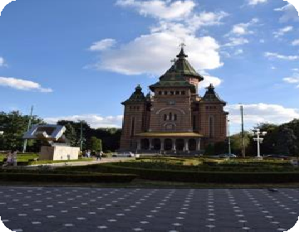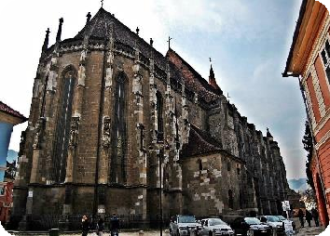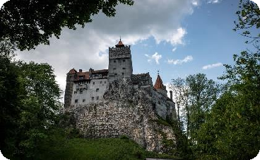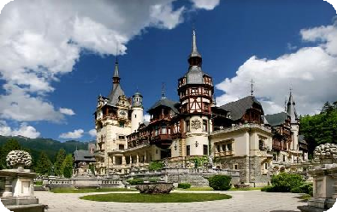

Transfer to Timisoara by passing Szeged

# Half Day English Speaking Guide

Timisoara orientation tour. Pass by / Photostop : Romanian National Opera, Metropolitan Cathedral

Overnight in Timisoara

|  |  |  |
| --- | --- | --- |
| **Day 03** | **TIMISOARA – BRASOV (B/-/D)** | **(Black Church)** |
|  | Breakfast at The Hotel |  |
|  | Transfer to Brasov  **Half Day English Speaking Guide**  **Entrance :** Black Church |  |
|  | Brasov orientation tour. Pass by / Photostop : St |  |
|  | Nicholas' Cathedral, Old Town Fortifications |  |
|  | Overnight in Brasov. |  |
| **Day 04** | **BRASOV – BRAN – SINAIA (B/-/D)** | **(Bran Castle)** |
|  | Breakfast at The Hotel |  |
|  | Transfer to Bran  **Half Day English Speaking Guide**  **Entrance :** Bran Castle |  |
|  | Transfer to Sinaia |  |
|  | Overnight in Sinaia. |  |
| **Day 05** | **SINAIA – VELIKO TARNOVO (B/-/D)** | **(Peleş Castle)** |
|  | Breakfast at The Hotel  **Half Day English Speaking Guide** |  |

Sinaia orientation tour. Pass by / Photostop :

Peleş Castle

Transfer to Veliko Tarnovo Overnight in Veliko Tarnovo.

# Day 06 VELIKO TARNOVO – SOFIA (B/-/D) (Boyana Church)

Breakfast at The Hotel Transfer to Sofia

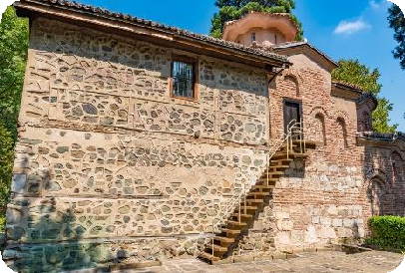

# Half Day English Speaking Guide

Sofia orientation tour. Pass by / Photostop : Alexander Nevsky Cathedral, Saint Sofia Church, National Art Museum, President Buildings, Boyana Church

Overnight in Sofia.

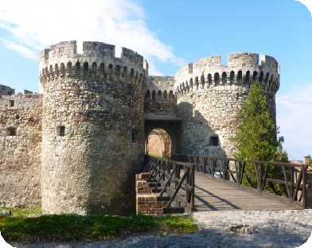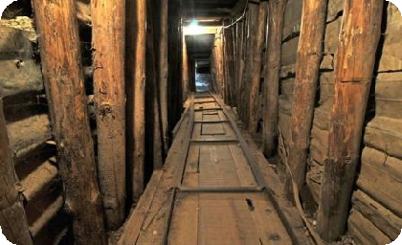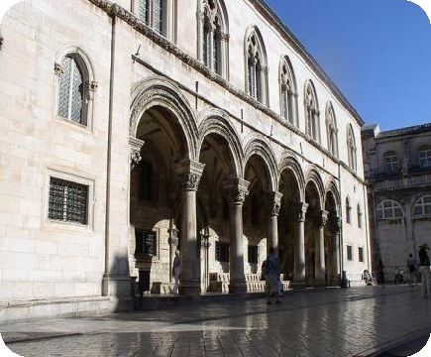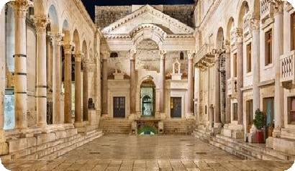

|  |  |  |
| --- | --- | --- |
| **Day 07** | **SOFIA – BELGRADE (B/-/D)** | **(Belgrade Fortress)** |
|  | Breakfast at The Hotel |  |
|  | Transfer to Belgrade  **Half Day English Speaking Guide** |  |
|  | Belgrade orientation tour. Pass by / Photostop : |  |
|  | The Republic Square, The National Theater and |  |
|  | The National museum, Bohemian Quarter |  |
|  | (Skadarlija), Kalemegdan Park, Belgrade Fortress, |  |
|  | Saborna Church, Knez Mihailova street. |  |
|  | Overnight in Belgrade. |  |
| **Day 08** | **BELGRADE – SARAJEVO (B/-/D)** | **(Sarajevo War Tunnel)** |
|  | Breakfast at The Hotel |  |
|  | Transfer to Sarajevo  **Half Day English Speaking Guide** |  |
|  | Sarajevo orientation tour. Pass by / Photostop : |  |
|  | Fire of Freedom, Old Library, Kursunlu Medresse, |  |
|  | Catholic Churches, Begova Mosque, Sebil, |  |
|  | Bascarsi Mosque, War Tunnel |  |
|  | Overnight in Sarajevo. |  |
| **Day 09** | **SARAJEVO – MOSTAR – DUBROVNIK (B/-/D)** | **(Rector’s Palace)** |
|  | Breakfast at The Hotel |  |
|  | Transfer to Mostar  **Half Day English Speaking Guide** |  |
|  | Mostar orientation tour. Pass by / Photostop : |  |
|  | Old bridge, Koski Mehmed Pasha Mosque, |  |
|  | Karagozbey Mosque, Mostar Bridge, Ottoman |  |
|  | Hamams & Homes and war Museum |  |
|  | Transfer to Dubrovnik  **Half Day English Speaking Guide** |  |
|  | Visit : Stradium Square |  |
|  | Dubrovnik orientation tour. Pass by / Photostop : |  |
|  | Orlando Sculpture, The Palace of Rector, The |  |
|  | Oldest Pharmacy of the Europe, Time Tower, War |  |
|  | Museum, Francis Monastery, Rector’s Palace |  |
|  | Overnight in Dubrovnik. Dinner at hotel. |  |
| **Day 10** | **DUBROVNIK – SPLIT (B/-/D)** | **(Diocletian’s Palace)** |
|  | Breakfast at The Hotel |  |
|  | Transfer to Split  **Half Day English Speaking Guide** |  |
|  | Visit : Old Town, Diocletian’s Palace |  |
|  | Overnight in Split. |  |

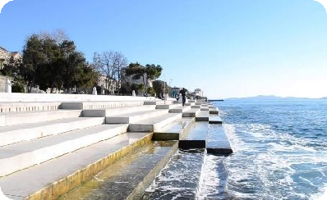

|  |  |  |
| --- | --- | --- |
| **Day 11** | **SPLIT – ZADAR (B/-/D)** | **(Sea Organ)** |
|  | Breakfast at The Hotel |  |
|  | Transfer to Zadar  **Half Day English Speaking Guide** |  |
|  | Visit : Sea Organ |  |
|  | Zadar orientation tour. Pass by / Photostop : Old |  |
|  | Town Area |  |
|  | Overnight in Zadar. Dinner at hotel. |  |
| **Day 12** | **ZADAR – PLITVICE – ZAGREB (B/-/D)** | **(Plitvice National Park)** |
|  | Breakfast at The Hotel |  |
|  | Transfer to Plitvice  **Half Day English Speaking Guide**  **Entrance :** Plitvice National Park |  |
|  | Transfer to Zagreb |  |
|  | Overnight in Zagreb. |  |

# Day 13 ZAGREB – DEPARTURE (B/-/-)

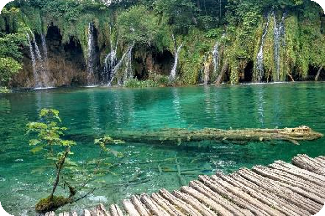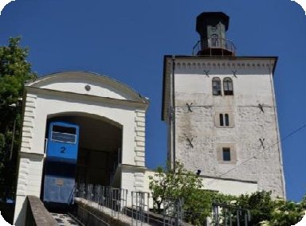

**(Lotrscak Castle)**

Breakfast at The Hotel

# Half Day English Speaking Guide

Zagreb orientation tour. Pass by / Photostop : Zagreb Square and the facades of ban Josip Jelacic Square Cathedral of the Assumption of the Virgin Mart. Stone Gate, St Mark Church and Pope`s Tower and Dolac Farmer’s Market, Lotrscak Castle

Transfer to airport End service

# Hotel –

|  |  |  |  |
| --- | --- | --- | --- |
| **Hotel Name** | **City** | **Rating** | **No . Of Nights** |
| Hotel Aquamarina or similar | **Budapest** | 4* | 01 |
| Hotel Timisoara or similar | **Timisoara** | 4* | 01 |
| Ramada Hotel or similar | **Brasov** | 4* | 01 |
| Ramada Hotel or similar | **Sinaia** | 4* | 01 |
| Arena Tarnovo Hotel or similar | **Veliko Tarnovo** | 3* | 01 |
| Vega Hotel or similar | **Sofia** | 4* | 01 |
| Tulip Inn or similar | **Belgrade** | 3* | 01 |
| Hollywood Hotel or similar | **Sarajevo** | 4* | 01 |
| Hotel Petka or similar | **Dubrovnik** | 3* | 01 |
| Hotel Katarina or similar | **Split** | 4* | 01 |
| Hotel Adria or similar | **Zadar** | 3* | 01 |
| I Hotel or similar | **Zagreb** | 3* | 01 |

* **Package Inclusions**
* 12 Nights accommodation at Hotels specified in the itinerary or similar.
* 12 Buffet Breakfasts.
* 12 Dinner ( No Pork / 3 Course Local / 5 Dish Chinese menu )

# Service of Long Distance coach as per the flow of itinerary

* FOC as per the slab.

# Package Exclusions :

* Early Check In and Late Check Out charges.
* Optional and Add-on tours unless mentioned otherwise.
* Porterage at The Airport
* Any High Season Surcharges / Peak Season Supplements etc.
* Any Airfare
* Visas
* Travel Insurance
* City taxes at the hotels
* Mandatory tips to coach drivers, guides & discretionary tips to waiters or any other local services.
* Anything not specifically mentioned in the “Tour Price Includes” column.

**Child Policy :** Infant ( 0-2.99 yrs) FREE

* + Child (3-7 yrs ) sharing room with 02 full paying adults without extra bed 55% of adult cost.
  + Child (8-11 yrs) sharing room with 02 full paying adults with bed 70% of adult cost.
  + Child (12-16 yrs) will be treated as an adult sharing room on triple occupancy depending upon Hotel policy.

# Important Notes : -

* Rates are valid for 72 hours
* Rates are nett and non - commissionable
* Rates do not include surcharges applicable during Trade Fairs / Peak Season / Public Holidays

/ Festivals.

* Hotels, rooms and services are subject to availability at the time of booking.
* **Standard Check In time for Hotels:** 1400 Hrs & **Check Out time:** 1100 Hrs
* Kindly note the quote is not valid during black out dates/fair period**.** During this time we reserve the right to charge a supplement and/or offer hotel outside the city limits.
* We may arrange the meal at hotel or restaurants .